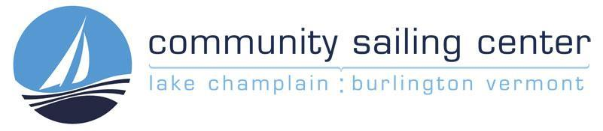

Program Director
Job Description
Overview
The Program Director is a leadership position in the organization for all aspects of the CSC’s Signature Programs, Summer Youth Camps, Adult Classes, High School Sailing, and any other Education-related events, classes, or camps. The Program Director leads the innovation and development of new programs, ensures that existing programs are staffed and operating safely, and has the ability to adjust and adapt to meet needs in the community .

Reports to: Executive Director
Classification: Permanent, full-time position
Compensation: Salaried, Health, Dental, and Wellness benefits; annual leave policy; retirement benefits; pay commensurate with experience

Prerequisite Required Skills, Education, and Experience:

- Minimum of a Bachelor’s degree; or 5+ years experience leading in an educational field;
- Experience developing and implementing programs and curricula;
- Ability to build and lead cohesive, successful teams;
- Exemplary interpersonal and communication skills (verbal and written);
- Flexibility, able to balance multiple competing priorities;
- Able to manage a budget, experience with financial oversight;
- Comfortable working in an administrative role in a vibrant and busy environment;

Desirable Skills, Education, and Experience:
- Minimum 1 year in sailing program leadership role;
- Basic dinghy and keelboat sailing knowledge and experience;
- First Aid Certification, CPR Certification, SafeSport Certificate, Concussion certificate;
- Small Boat and/or Keel Boat Instructor Certification and Vermont Boater’s License;
- Knowledge of US Sailing curriculum for both youth and adult instruction;
- Previous experience working for an on-water recreation entity (marina, Yacht Club, Shipyard)
- Well connected with community nonprofit leaders and education professionals;

Responsibilities
Program Planning & Implementation
Responsible for the organization, development, operation and coordination of all Educational Programming, which includes Signature Programs, Summer Youth Camps, and Adult Classes.
Activity to support Program Planning & Implementation includes:

- Budgeting, Setting Pricing, and Resource Planning.
- Planning and Design of Curriculum.
- Identifying resource requirements (staffing, boats, infrastructure, materials).
- Outreach, Recruitment and Partnership Development and Cultivation with nonprofits and educators.
- Recruiting, Hiring, Training, Cultivating, and Retaining high-quality instructors and AmeriCorps members.
- Assessment, Evaluation, and Reporting of all program implementation and outcomes.
- Support Marketing Through Content Development to ensure camps and classes are well attended.
- Booking, scheduling, and coordinating group sails and programs.

Financial and Data Management
- Support Development and Communications Manager to complete grant proposals and donor reports.
- Actively manage daily transaction oversight to ensure accuracy.
- Regular review of revenue and expense to ensure programs remain on budget.
- Responsible for setting annual scholarship funds and ensuring targets are met.
- Collect and manage data related to social impact, and participate in reporting to leadership and board.
- Analyze data and identify opportunities for innovation and improvement.

Human Resource Management
1. Create and implement an annual instructor recruitment strategy.
2. Collaborate with the Operations Director to identify all staffing needs.
3. Recruit, screen, hire and conduct all required HR administration.
4. Lead the Annual Training Week of all staff, including waterfront managers and coordinators.
5. Responsible for all professional development, cultivation, retention and advancement of talent.
6. Oversee record keeping of all HR-related documentation.
7. Oversee programmatic, instructional and waterfront staff scheduling.
8. Coordinate with SerVermont to incorporate Americorps member service to support Signature Programs.

Risk Assessment and Safety Management
- With the other Directors identify, assess, monitor, and report risks associated with the programs.
- Support development and implementation of the Emergency Action Plan.

Additional Support
1. Assume Manager on Duty responsibilities as needed: staff supervision (responding to no-shows), on-water safety, etc.
2. Assume additional management team duties as directed including: assisting with fundraising events, attending and/or presenting at relevant trade shows, volunteer fairs and organizations meetings as needed, assisting with office supervision and management, and intra office communications.

